SurfGallery (100 points)
Create a Web page (HTML5 + CSS3 + images) that looks like the screenshot below:
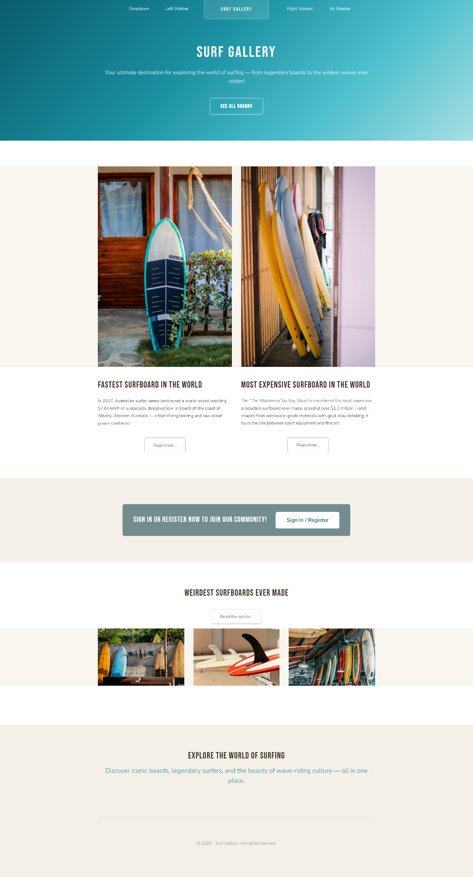

You are given the above screenshot + all required text and image url’s.

Output
The output should be valid HTML5 + CSS3 + images that implement the above web page.

Constraints
- Use font (https://fonts.googleapis.com/css2?family=Bebas+Neue&family=Nunito:wght@300;400;600&display=swap)
- The site should open correctly in the latest version of Chrome

How to Submit the Assignment
- Folder Structure Your folder must be named exactly: 03_SurfGallery_Task and contain the following files:
  - index.html
  - styles.css

- Package all three tasks into one .zip file, with each task in its own separate folder following the naming convention above

